MS Teams- A guide for parents and pupils
Introduction
Microsoft Teams is a piece of software offered within Microsoft 365 that allows teams to come together and work collaboratively in a remote environment. Amberley Parochial Primary School will be using the Teams software to provide remote learning in the event of prolonged absence from school due to Coronavirus Covid-19. The software will be used by teachers, teaching assistants and pupils. The following document gives a quick start guide to using the basics of the software.
Step 1 - Logging on to Teams
Microsoft Teams is easy to access via any web browser by completing the following steps:
- Using any web browser, go to www.office.com. This will open up the Microsoft Office 365 login page as shown below:

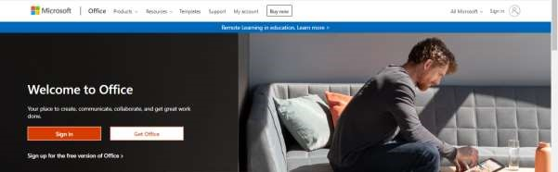

- Select the sign in tab which will take you to the following log in page:
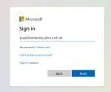
- Enter your school email address (found on the sticker in the front of the home learning book).
(All staff and pupils have an assigned email address that incorporates the individuals first initial and surname name followed by @amberley.glous.sch.uk. eg jbloggs@amberley.gloucs.sch.uk)

- Select Next and enter the password for the account (also on the sticker in the front of the home learning book)

- The Office 365 software will open on your home page. From this home page, many of the apps within Office 365 can then be accessed through either selecting them from the menu on the left hand side of the screen (as highlighted below) or by selecting them via the app launcher option at the top left of the screen.

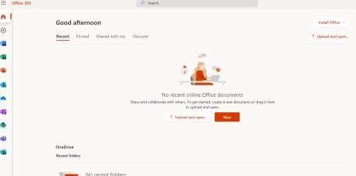

- For remote learning the Teams App will be used. Select it from the either the menu on the left hand of the screen or via the App Launcher.
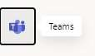
- Once Teams has been selected, the software will open in a new web page. This is what is referred to as the ‘web app of Teams. You can also download the app to your device and will be offered the option to do this when you first open Teams.

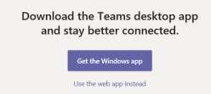

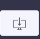
If you wish to download the app at any other time, click on the download symbol in the bottom right hand side of the screen:

- Each child’s team page will look different depending on the number of teams they have been added to. Most will have a class team, but others may have additional teams set up for year group specific content. Only teams which your child has been entered into will be visible.

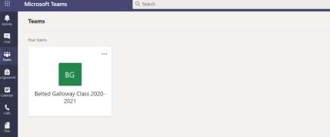

- To enter a class team (e.g. the platform where the remote learning for the individual classes will take place) double click on the team.

- The home page for that team will open up. An example is shown below:
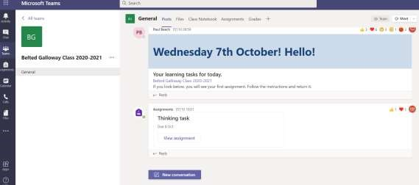

Understanding the layout:

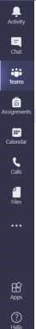
The App bar

Notifications will appear here when work is assigned etc

Chats written in this area are visible to anyone in the main team.

Takes you back to the main Team page which shows the teams you are in.

Lists the assignments which have been given to you.

Details meeting times and dates. Meetings can
be accessed through the
calendar.

Direct access to class files uploaded by staff
.

The ‘General’ channel feed
Each day, your teacher will post an announcement explaining the format of the day’s learning. This will be headed with the date. You can scroll back through previous posts if you need to revisit a previous day. It will outline the expectations of the day, when meetings will take place and what work you have been assigned. Meetings will also be placed on the calendar.
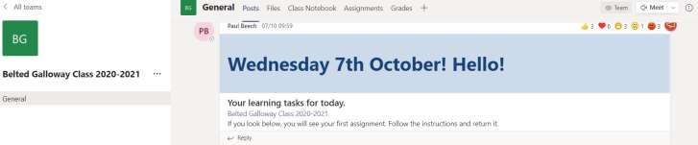

Accessing assignments
Children will receive notifications of the assignments they are being asked to complete. These can be accessed through the tab at the top of the general channel feed section. If you are within more than one team, a list of all your assignments can be accessed through the left had side ‘assignments’ tab.

To open the assignment, simply click on it. You will then see a set of instructions and details of when the task is due. To open the attached file, click on the three dots and select whether you wish to complete it on screen, by selecting ‘open in word’ or whether you wish to download and print it, before working without a computer.

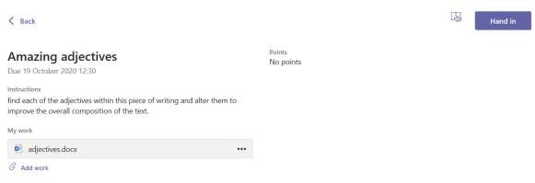

Returning an assignment
Once an assignment has been completed, you will have the option of handing it in. If you have worked on the computer, save your work to your own computer and then upload it by clicking on ‘Add work’, ‘Upload from this device’ and then selecting the correct file, before clicking on ‘Hand in’.
If you have worked in your home learning book, or on a printed version of the worksheet, take a clear photo of your work, or scan it, save it to your computer and then attach it using the ‘Add work’ option as above.
To return work via a mobile device (Android/ iOS): open the Teams app, tap ‘assignments’ at the bottom of the screen, tap ‘completed’, then tap the assignment you want to send.
Your work will then have been submitted back to your teacher, who will respond as necessary. Any responses made personally to you about your work will not be able to be seen by any other pupil. Notifications of feedback will appear as an alert in the ‘activity’ tab on the top left of the screen.

Live meetings
During the day, there will be a mixture of live lessons, pre-recorded content and independent tasks. Teachers will invite you to meetings using the Teams Calendar. You can join the meeting by clicking on the link in the General feed, or through the calendar. Simply click the ‘Join meeting’ link.

Meetings will be recorded and when they are finished, they will appear in the General feed and will be available for download for 20 days. If you are unable to attend a meeting, please feel free to watch the recorded session at a more convenient time, however, we would be grateful if you could inform your teacher that this is your intention.
To gain entry to a meeting, click on the calendar and find the meeting you are due to attend. Double click on that meeting and you will be taken to the lobby. You will need to click the relevant options for allowing the use of your camera and microphone, and will need to join using the computer audio in order to hear what is going on.

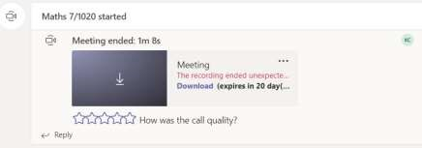

During a meeting
Children are expected to have their camera on, but to be muted (microphone off) unless otherwise instructed.
Before a meeting starts, you will be placed into a ‘lobby’ until your teacher is ready to start the meeting.
To gain the attention of the teacher, eg to ask a question, please click on the raise hand icon.

To type a question, please use the chat icon (though obviously this chat is designed to be specific to the online meeting, and should be used appropriate comments only.)

