Topic: | Skills |  | Key Vocabulary
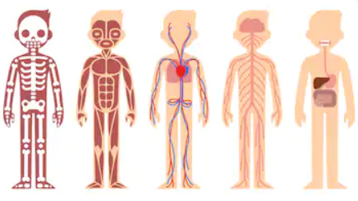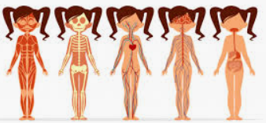  Humans | - I can identify name, draw and label the basic parts of the human body  - I can say which part of the body is associated with each sense  - I know that humans, have offspring which grow into adults  - I can explain what humans need to survive  - I can explain why humans should exercise  - I can explain why hygiene is important  - I can talk about different types of food |  | Offspring  Foetus  Baby/Toddler  Childhood  Adolescence  Adulthood  Elderly | Senses including body parts Protein  Carbohydrates  Dairy  Fruit & Veg  Hygiene  Exercise
Subject: | Duration |  | Celebration:
Science | WC 11.11.19 (2 weeks)
Things to support learning at home: |  | Focus Value/Learning Power:
-Discuss key vocabulary  -Name and locate body parts and their uses  -Identify food and the group they belong to  -Find out about need for exercise and a healthy, balanced diet |  | - Be curious  - Thankfulness

